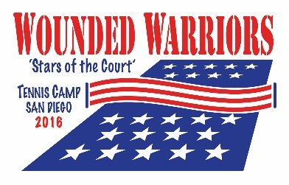

The 5th Annual National Wounded Warrior Tennis Camp thanks the many volunteers who donated their valuable time and energy to the camp’s success!

Camp Committee

Steve Kappes Geoff Griffin Cara Beltran
M. A. Hillier Spike Lowndes Manuela Griffin
Mary Ann McCauley Colin Chang Josh Jorgensen
Bryan East Denise Lyon

Massage Therapists

Tai Guo Danielle Ritchie Elaine Bowen
Jamye Krawiec Michelle Alhambra Gina Sullivan
Mike Larsen

Nurses-Medical Staff

Cindy Brunz HN Steven Randall HN Tavon Borja
Kristi Gonzalez

Photographers

Alisal Luke Griffin Patrick Steele
Andy Ko

TSA, Airport Ambassadors, and Transportation Volunteers

Gina Bernsen Everett Lucio Tommy and Carolynne Yen
Ginna James Antony Brock Stacie and Andrew Hunt
Kim Johanson Kris and Evan Benham Catherine and Patrick Henson
Beth and Matt Dammeyer

Camp Volunteers

Laurie Mychaels Jim and Maureen Manos Pat Newman
Rick Beltran Lisa Brown Emily Jia
Beth Dammeyer Al Walters Bill Bauer
David Hartzell Kristine Hansen Nellie Munoz
Andrew Hoffman Jeebee Kim April Buchner
Stephanie Erickson Greg and Connie Follis Kathy Nichols
Grace Friebe Patty Liu Chamu Chimhau
Susie MacDonald Pia Garcia Patti Coffee
Michael Rodrigues Steve Leffler

